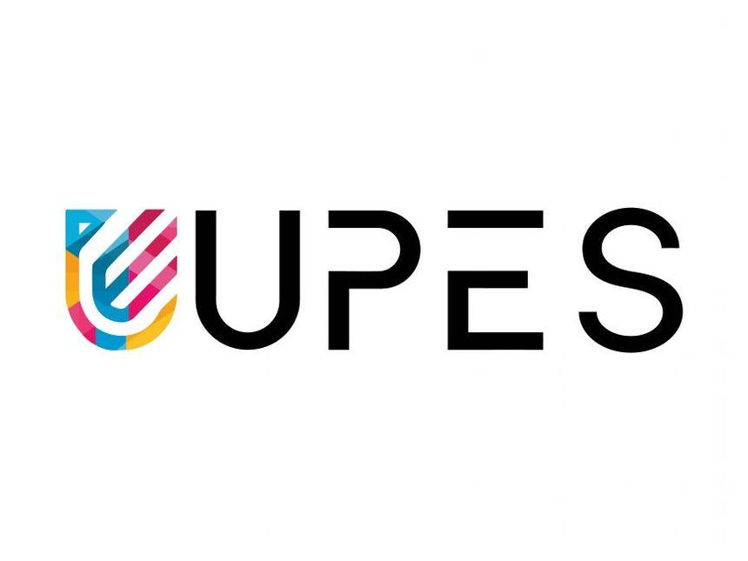
PYTHON PROGRAMMING LAB FILE

Name: Krishna Som
Sap ID: 590025475
Batch: 34
Teacher: Sugandha Sharma

Assignment 2:
Q1. OOP Fundamentals & Class Implementation (20 Marks)
(a) Theory (10 Marks)
Explain the following OOP concepts with suitable examples:
- Encapsulation
- Abstraction
- Inheritance
- Polymorphism
Sol:
Encapsulation
Encapsulation means binding data (variables) and methods (functions) together in a single unit (class) and restricting direct access to some components.
Example:
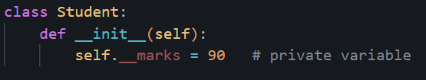
Abstraction
Abstraction means hiding implementation details and showing only essential features.
Example:
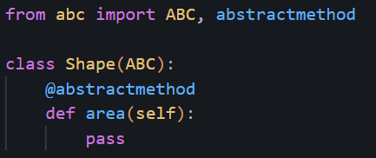
Inheritance
Inheritance allows one class to acquire properties of another class.
Example:
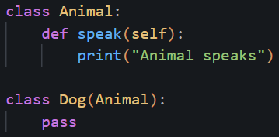
Polymorphism
Polymorphism means same function name behaves differently.
Example:
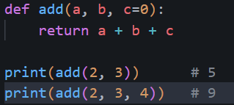
(b) Programming
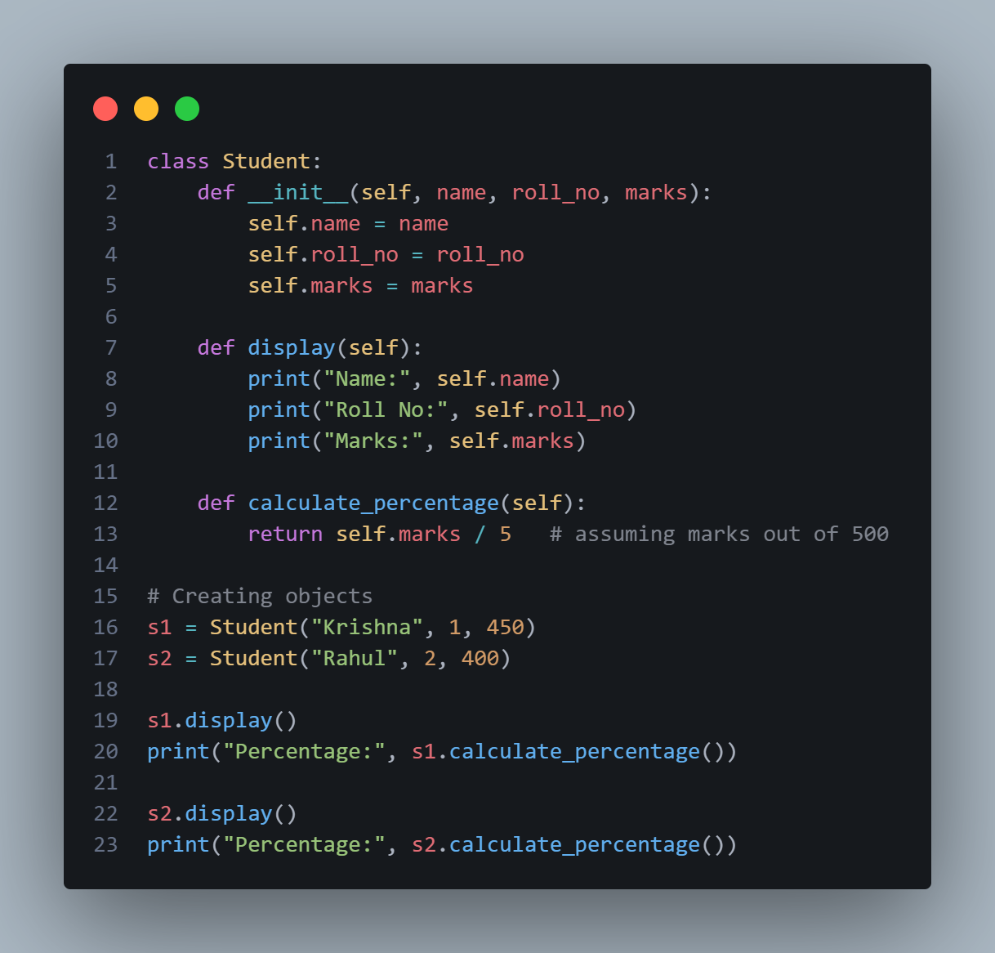
Output:
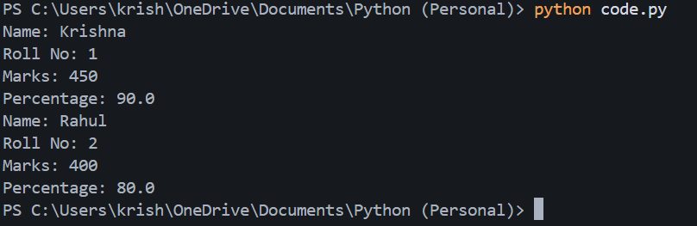
Q2. Constructors, Variables & Data Members

(a) Theory (10 Marks)
Differentiate between:
- Class variables vs Instance variables
Sol:
Class Variables vs Instance Variables
Class Variable | Instance variable
Class variables are shared among all objects of a class, so every instance accesses the same value. | Instance variables are unique to each object, so every instance has its own separate value.
Class variables are defined inside the class but outside any method. | Instance variables are defined inside the constructor using the self keyword.

Public vs Private Members
Public | Private
Public members can be accessed from anywhere in the program without any restriction. | Private members cannot be accessed directly from outside the class.
Public members are declared normally without using any special symbols. | Private members are declared using a double underscore (__) before their name.

(b) Programming
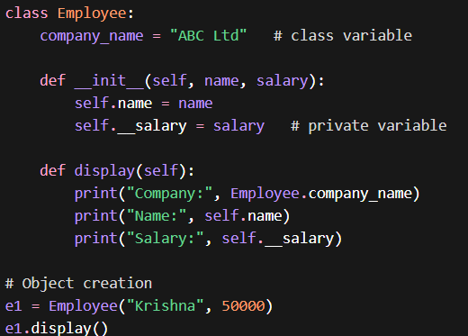
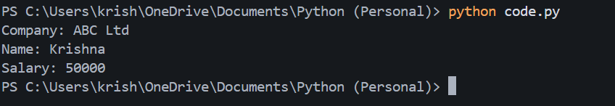

Q3. Inheritance
(a)Theory
Explain types of inheritance:
- Single
- Multiple
- Multilevel
Sol:
1. Single Inheritance
One class inherits from another.
2. Multiple Inheritance
A class inherits from more than one class.
3. Multilevel Inheritance
A class inherits from a class which itself is inherited.
(b) Programming
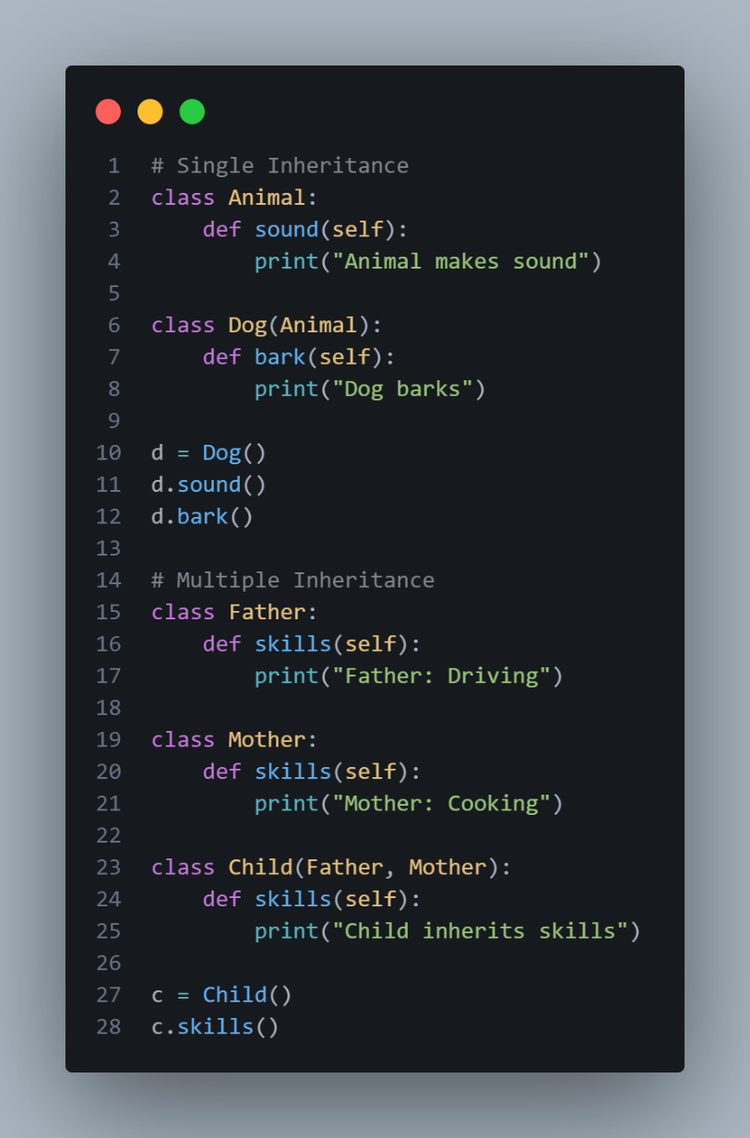
Output:
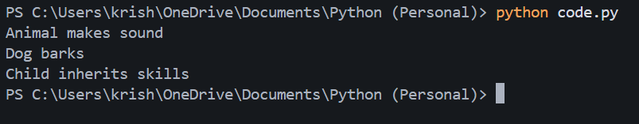

Q4. Polymorphism & Special Methods
(a)Theory
Explain:
- Method Overriding
- Operator Overloading
Sol:
Method Overriding
When a child class provides its own implementation of a parent class method.
Operator Overloading
Using special methods like __add__() to define operators for objects.
(b) Programming
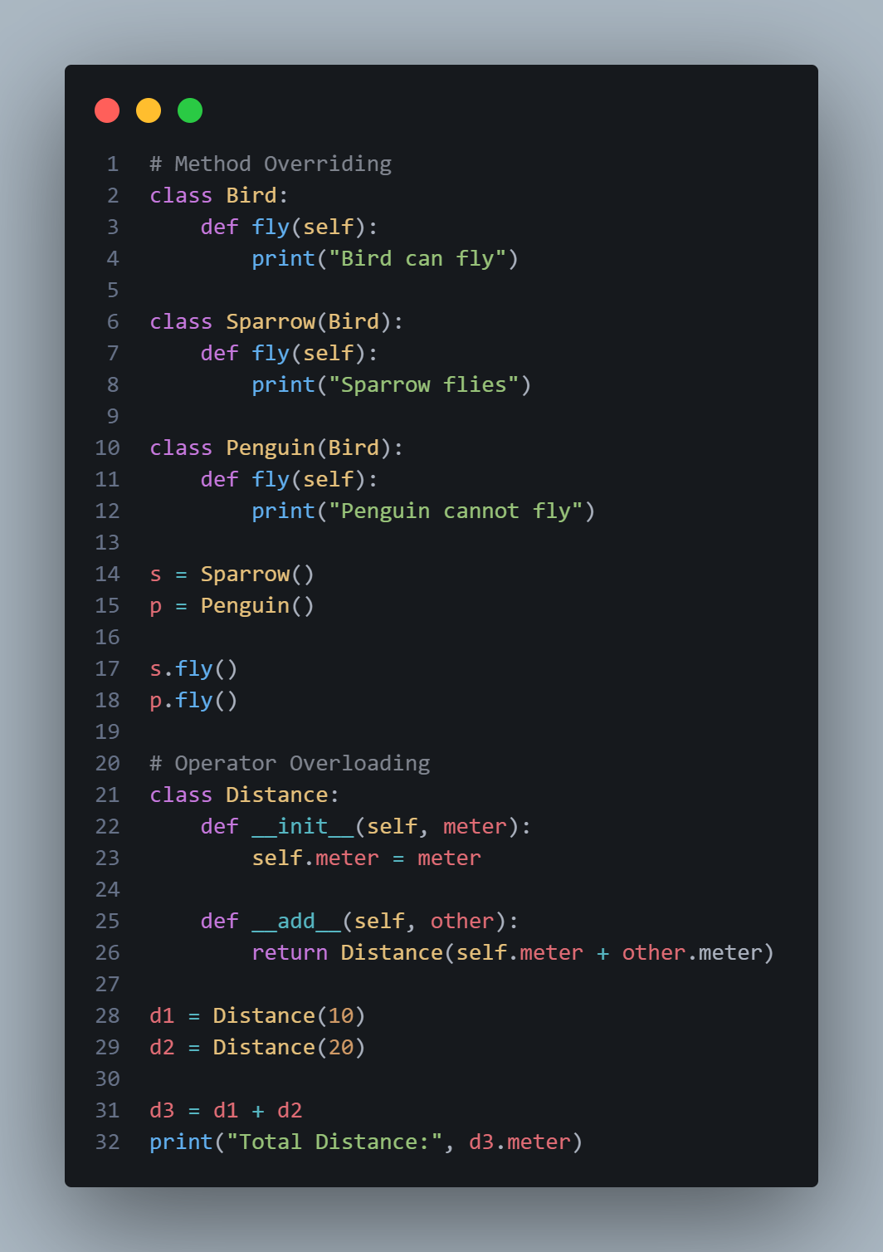
Output:
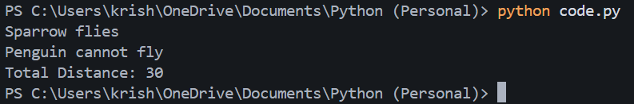

Q5. Advanced OOP Concepts
(a)Theory
Explain:
- Abstract classes
- Garbage Collection
- Built-in class attributes (__dict__, __name__, etc.)
Sol:
1. Abstract Classes
Classes that cannot be instantiated and contain abstract methods.
2. Garbage Collection
Automatic memory management that deletes unused objects.
3. Built-in Class Attributes
- __dict__ → shows attributes
- __name__ → class name
- __module__ → module name

(b)Programming
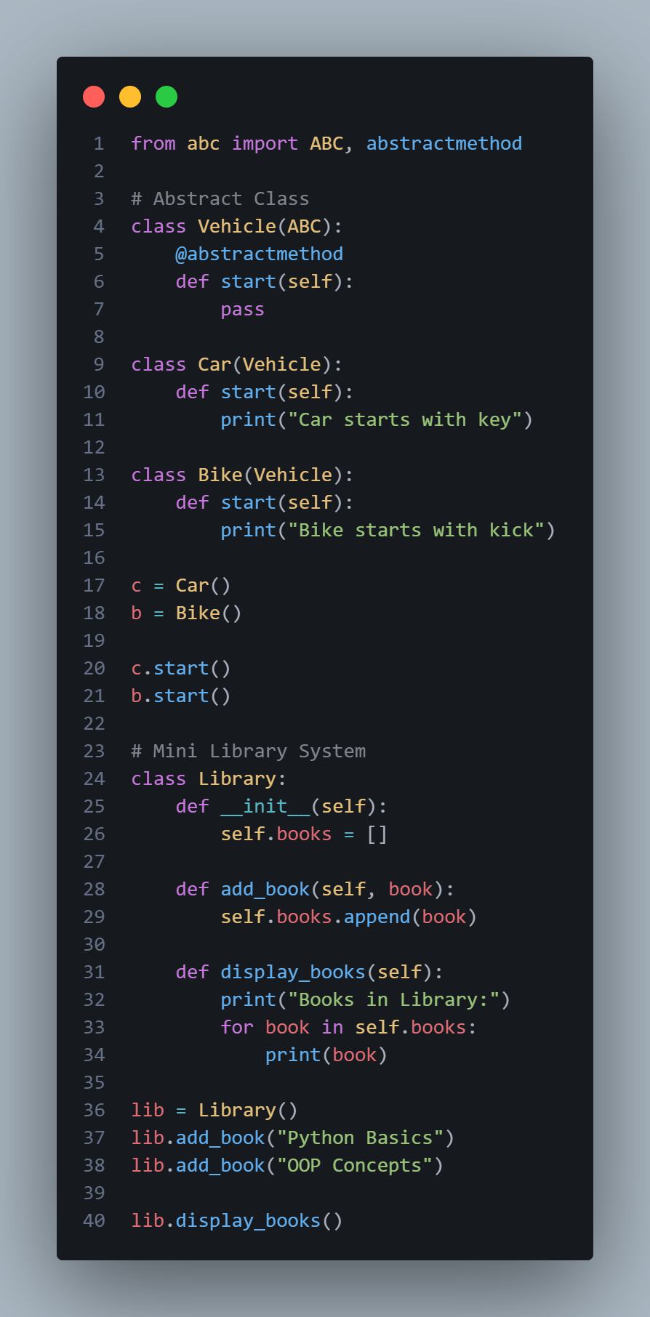

Output:
